The National University of Lesotho
Department of Mathematics and Computer Science
Faculty of Science and technology

CS4433: Software engineering
Task: Project Management Plan
Due: 04th October 2026
Participant:
 | Student Number | Surname, initials | Major
 | 202322798 | T’soeu, D. T | B. Sc. IS

Table of Contents
1.Feasibility Study 3
1.1 Technical feasibility 3
1.2 Operational feasibility 5
1.3 Economic feasibility 6
1.4 Legal and ethical feasibility 7
1.5 Schedule feasibility 9
1.6 Overall feasibility recommendation 10
2.Work Breakdown Structure and Gantt Chart 11
2.1 Work Breakdown Structure 11
3. Risk Management 13
3.1 Initial Risk Register 13
3.2 Risk Register Tracking Across Phase Gates 16
Risk Status 18

1.Feasibility Study
Feasibility was assessed before detailed development to determine whether the proposed LMS can be delivered within the available seven weeks, using the required tools and within the stated scope. The assessment considers technical, operational, economic, legal and schedule feasibility.

1.1 Technical feasibility
The project is technically feasible because the required technologies are mature, available and suitable for a small offline information system.

- C++17 supports object-oriented design, inheritance, polymorphism, exception handling and strong compile-time checking.
- SQLite is appropriate for a single-computer or local-network application because it is lightweight, requires no separate database server and supports transactions, constraints and indexing.
- CMake can provide repeatable builds across development and assessment environments.
- GoogleTest or Catch2 can support automated unit and integration testing required by the V-Model.
- Git and a hosted repository can provide version history, branches, tags and evidence of configuration management.
- A layered architecture with a user interface, service/business layer and data-access layer will reduce coupling and make the core rules easier to test.
- The expected capacity of approximately 800 students is modest for SQLite if queries are parameterised, appropriate indexes are used and transactions are applied correctly.

The main technical challenges are secure password storage, correct handling of dates and deadlines, consistent enforcement of role permissions, and accurate mark auditing. These are manageable if they are designed early, implemented through centralized services, and covered by boundary and integration tests.

Technical conclusion: Feasible, provided that the design is kept within the agreed scope and security-sensitive functionality is implemented using recognized libraries rather than custom cryptography.

1.2 Operational feasibility
The system is operationally feasible because it directly addresses the school’s current needs and constraints. It can work offline, which is important because the school’s internet connection is unreliable. The four roles correspond to existing responsibilities, so the system can fit the school’s workflow without requiring a new organizational structure.

The principal’s requirement for simplicity can be addressed through a role-specific menu, clear labels, validation messages and a small number of predictable workflows. Lecturers will be able to create assignments, grant extensions, mark work and provide feedback. HoDs will be able to moderate marks before release, while administrators will manage accounts, departments, courses and enrolments.

Operational risks remain. Staff may initially be unfamiliar with the system, and inconsistent use of extension or moderation rules could reduce confidence in the results. These risks will be addressed through a short user manual for each role, sensible defaults, input validation, confirmation messages and acceptance testing with representative workflows.

Operational conclusion: Feasible, if usability is treated as a requirement and role-based workflows are demonstrated during acceptance testing.

1.3 Economic feasibility
The proposed solution is economically feasible for the case study because it uses low-cost or open-source tools and does not require a paid cloud service, dedicated database server or continuous internet connection. The main cost is the student’s development time over seven weeks.

Cost or benefit | Assessment
Software tools | C++ compiler, CMake, SQLite, Git, testing tools and static analysis tools are available at no or low cost.
Hardware | Existing school computers are expected to be sufficient for a lightweight local application.
Infrastructure | No hosting subscription or always-on internet service is required.
Training | Limited training is expected because each role will have a focused interface and manual.
Maintenance | A layered design and automated tests should reduce the cost of future changes.
Expected benefits | Less manual record keeping, fewer mark-release errors, better accountability and faster access to assessment information.
The project does not attempt to build expensive features such as video conferencing, automated grading or plagiarism detection. Excluding these features keeps the solution proportionate to the school’s immediate need.

Economic conclusion: Feasible and cost-effective for the stated scope, particularly because existing hardware and open-source technologies can be used.

1.4 Legal and ethical feasibility
The system is legally and ethically feasible, but it will handle sensitive learner information and assessment records. The implementation must therefore comply with applicable Lesotho data-protection, privacy, education and cybercrime requirements, together with the school’s information-security policies. The final deployment should be reviewed by the school or institution’s authorized data-protection representative before real learner data is entered.

The main controls will be:

- storing salted password hashes rather than plain-text passwords;
- applying least-privilege, role-based access;
- preventing students from viewing marks before HoD release;
- recording who changed a mark, when it changed, the old value, the new value and the reason;
- validating input and using parameterized SQL queries;
- limiting access to personal and assessment data to legitimate school purposes;
- providing a process for correcting inaccurate records;
- protecting backups and restricting access to the database file;
- documenting retention and deletion decisions with the school;
- considering accessibility, including readable text, keyboard-friendly navigation and clear error messages; and
- applying the late-penalty rule consistently while allowing approved extensions and recording exceptional decisions.

The project will not claim that a prototype is legally certified. Instead, legal compliance will be treated as a design constraint, and any unresolved policy decision will be recorded as an assumption or issue for the school to approve.

Legal and ethical conclusion: Feasible with controls. The system can be developed responsibly, provided privacy, security, fairness and accessibility are designed into the system and reviewed before deployment.

1.5 Schedule feasibility
The schedule is demanding but feasible for an individual project because the assignment provides a defined scope, a fixed seven-week sequence and clear deliverables. The most important constraint is the dependency between requirements, design and implementation: incomplete requirements or a late Gate 2 would directly reduce implementation and testing time.

Schedule controls will include:

- baselining the SRS at Gate 1;
- completing the design and obtaining Gate 2 approval before implementation;
- developing the highest-priority Must requirements first;
- using a small, testable architecture rather than adding unnecessary features;
- working on documentation and test cases alongside development;
- reserving time for integration, regression testing and defect correction; and
- using the change-control process for CR1 rather than allowing uncontrolled scope growth.

Schedule conclusion: Feasible but high risk. The plan is achievable if the scope is controlled, gates are respected and progress is reviewed at the end of each week.

1.6 Overall feasibility recommendation
The project is recommended to proceed. The technical solution is suitable for the offline school environment, the operational benefits are clear, the costs are low, and the legal and ethical risks can be reduced through appropriate controls. The principal condition is strict scope and time management. The project should prioritize the Must requirements and core assessment workflow before optional improvements.

Recommendation: Proceed with development, subject to the following conditions:

- Requirements and business rules are agreed and baselined at Gate 1.
- The design passes Gate 2 before implementation begins.
- Security, auditability and mark visibility are treated as non-negotiable controls.
- CR1 is implemented only after version 1.0 is stable and its impact has been analyzed.
- The risk register is reviewed at every gate and corrective action is recorded.

2.Work Breakdown Structure and Gantt Chart

2.1 Work Breakdown Structure

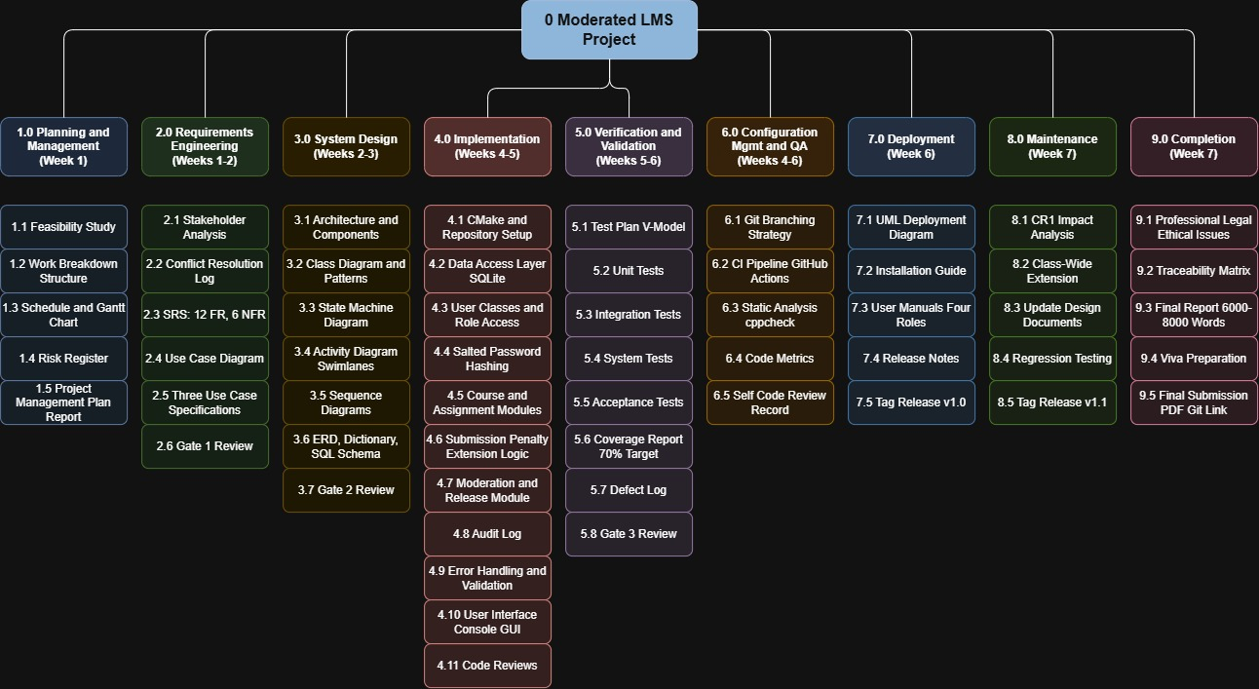
2.2 Gantt chart
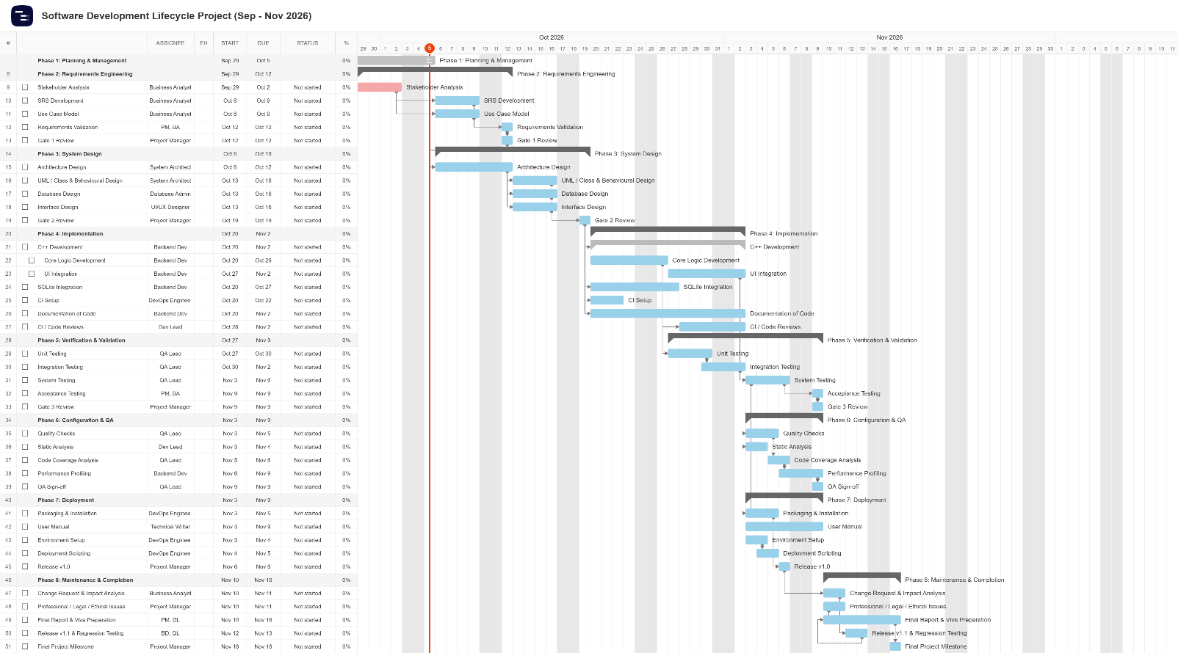

3. Risk Management
Initial Risk Identification
Risks are identified early in the project by looking at what could go wrong, how likely each issue is to happen, and how serious its effect could be. Each risk is then given a responsible person who will monitor it and make sure the agreed mitigation is carried out throughout the different stages of the project.

3.1 Initial Risk Register
Risk exposure is calculated using the following formula:
Exposure = Likelihood (1–5) × Impact (1–5)
Risk ID | Category | Risk Description | Likelihood | Impact | Exposure | Mitigation Strategy | Owner
R-1 | Technical | SQLite may experience database locking or slowdowns when several users try to access the database at the same time. | 2 | 4 | 8 | Enable SQLite Write-Ahead Logging (WAL) and make sure database transactions are handled correctly. | Tech Lead
R-2 | Technical | C++17 code may contain memory leaks or pointer-related errors that could cause the system to behave unexpectedly or crash. | 3 | 4 | 12 | Use smart pointers such as std::unique_ptr, follow RAII principles, and run Valgrind checks to identify memory leaks. | Lead Dev
R-3 | Technical | Poor password security could result in passwords being exposed or stored in an unsafe form. | 2 | 5 | 10 | Store passwords securely using a salted key-derivation method such as Argon2id or bcrypt, with a unique salt for each account. | Security Lead
R-4 | Project | Development of the C++ and SQLite data access layer may take longer than planned and delay the overall project schedule. | 3 | 3 | 9 | Create a basic SQLite wrapper prototype by Week 2 and avoid adding non-essential features until the core system is working. | PM
R-5 | Project | The project may fail to reach the required minimum test coverage of 70%. | 3 | 3 | 9 | Add automated coverage checks using tools such as gcov/lcov to the CI pipeline so coverage can be monitored continuously. | QA Lead
R-6 | People | Different stakeholder expectations about moderation may lead to disagreements, changes, and additional development work. | 3 | 4 | 12 | Agree on and document the required state transitions during Phase 2 so that the requirements are clear before development continues. | Analyst

3.2 Risk Register Tracking Across Phase Gates
The risk register is reviewed at each major phase gate to determine whether previously identified risks have increased, decreased, or been fully resolved. When mitigation activities are completed, the likelihood and impact scores are reassessed and the resulting exposure is recorded.
Phase Gate | Trigger Event | Affected Risk | Action Taken & Status | Updated Exposure
Gate 1 – Requirements Review (Day 11) | Stakeholder analysis completed | R-6 | Conflicting requirements regarding grade visibility were identified and resolved in the SRS state machine. [Closed] | 4 (L=1, I=4) Closed
Gate 1 – Requirements Review (Day 11) | SQLite prototype successfully verified | R-4 | The data access layer (DAL) design was validated early, reducing the likelihood of schedule delays. [Active] | 6 (L=2, I=3) Active
Gate 2 – Design Review (Day 21) | Architecture and UML design finalized | R-2 | The use of smart pointers, particularly std::unique_ptr, was included in the class design to reduce the risk of memory-related errors. [Active] | 6 (L=2, I=3) Active
Gate 2 – Design Review (Day 21) | Security strategy finalized | R-3 | The use of salted password hashing was incorporated into the database access layer design. [Active] | 5 (L=1, I=5) Active
Gate 3 – Verification & Validation Review (Day 39) | Automated testing completed | R-1 | Stress testing was completed successfully with SQLite WAL mode enabled, with no significant database locking issues identified. [Closed] | 2 (L=1, I=2) Closed
Gate 3 – Verification & Validation Review (Day 39) | AddressSanitizer checks completed | R-2 | Testing found no memory leaks or significant memory-related errors across the test suite. [Closed] | 2 (L=1, I=2) Closed
Gate 3 – Verification & Validation Review (Day 39) | Test coverage report completed | R-5 | Unit testing achieved 82% line coverage, exceeding the required 70% target. [Closed] | 3 (L=1, I=3) Closed

Risk Status
A risk is marked Active when it still requires monitoring or further mitigation. A risk is marked Closed when the planned mitigation has been completed and the remaining exposure is considered sufficiently low.
The exposure score is recalculated at each relevant phase gate using:
Exposure = Likelihood × Impact
This ensures that the risk register reflects the project's current situation rather than relying only on the original risk assessment.

